ASSIGNMENT  
To make a smart home using tinkercard with more than two sensor ,led & buzzer

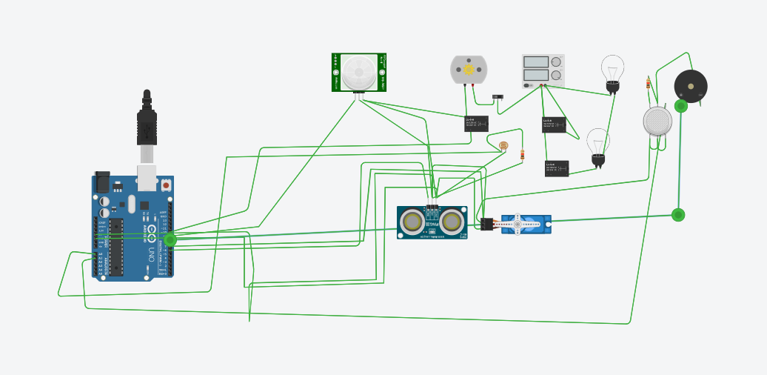

int pirsensor = 0;  
void setup()//the setup routine runs once when you press reset  
{  
pinMode(13,OUTPUT);//initialize digital 13 pin as an output  
pinMode(12,INPUT);//initialize digital 12 pin as an input  
}  
void loop()//the loop routine runs multiple times  
{  
pirsensor = digitalRead(2);  
if (pirsensor==HIGH)  
{  
digitalWrite(13,HIGH);  
delay(10000);  
}  
else  
{  
digitalWrite(13,LOW);  
delay(120);  
}